http://librarysupportedinquiry.weebly.com/
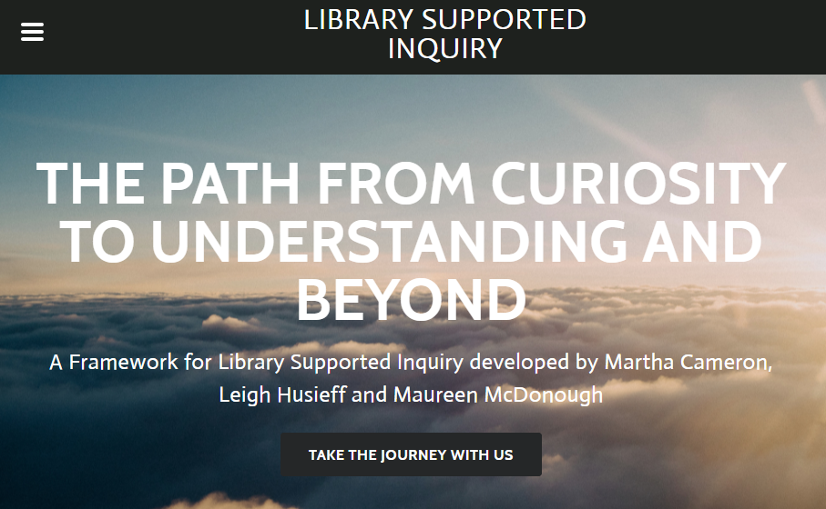
Welcome to
Library Supported Inquiry: The Path from Curiosity to Understanding and Beyond
Here is what you will find on our website:
- Introduction to Inquiry – what is it and why it is important
- Schedules for running an Inquiry program
- The important process of Building Knowledge and Exploring Ideas
- How to Identify Resources & Choose a Topic
- Information Literacy skills including Collecting Information, Taking Notes, Summarizing, Paraphrasing and more
- Plagiarism and Research Ethics instruction
- Advice on Analyzing, Synthesizing & Creating a project
- Tips on Presenting & Sharing
- Questions for Reflection and a comprehensive Evaluation rubric
- Sample Projects (to come)
Our goals in creating this website are firstly, to build a rigorous, comprehensive Inquiry program where a Teacher-Librarian plays an important role, and secondly, to make all the necessary resources available in one place. Our project is a work in progress, and we anticipate adding to the website on an on-going basis.
